Your Name: STEPHEN OMONDI  
Your SUID: 946934043  
Your Email: SOOMONDI@SYR.EDU  
Date Due: 2019-12-08  
Homework #: LABWORK 10

# Exercises

Complete each of the following exercises. If you are unsure how to accomplish the task, please consult the coursework videos where there are explanations and demos.

1. Write KSQL to create a stream named **weblogs** from the JSON keys in the **weblogs** Kafka topic. Make sure to set the TIMESTAMP property to the timestamp from the stream.

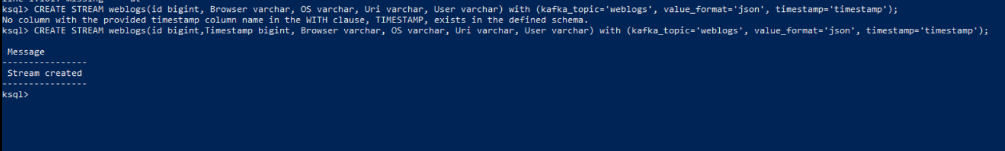  
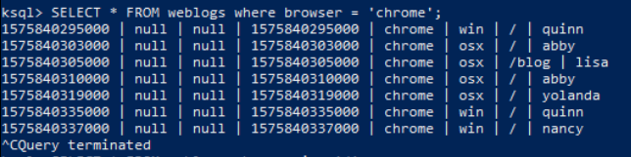

1. Write a KSQL statement create a persistent stream/table called **homepage** which only displays visitors to the root of the website (/). It should display all columns from the **weblogs** stream.

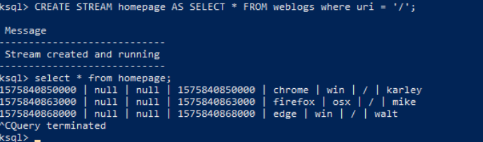

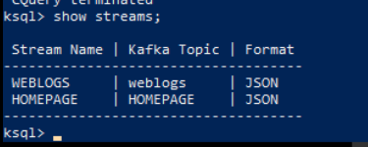

1. Write a KSQL statement to count operating systems users (os) in 60 second windows. After 60 seconds, the counter should reset, and counts should begin again.

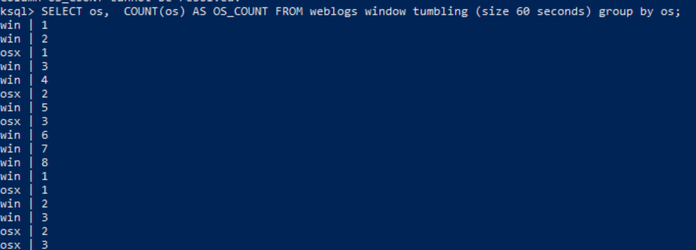

1. Write a KSQL persistent stream/table called **user_activity** which will display a count of user activity on the website within 1-minute sessions.

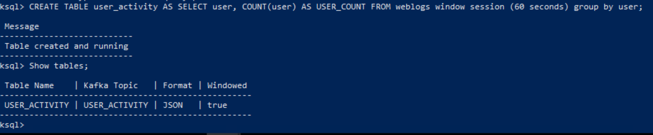

1. Write a KSQL statement to display users who have more than 1 pages of activity in a 1-minute session.

